TASK 1 = CREATING ER DIAGRAMS

CREATE DATABASE Ticket_System;

USE Ticket_System;

CREATE TABLE Venue (

venue_id INT PRIMARY KEY AUTO_INCREMENT,

venue_name VARCHAR(255) NOT NULL,

address TEXT

);

CREATE TABLE Event (

event_id INT PRIMARY KEY AUTO_INCREMENT,

event_name VARCHAR(255) NOT NULL,

event_date DATE NOT NULL,

event_time TIME NOT NULL,

venue_id INT,

total_seats INT NOT NULL,

available_seats INT NOT NULL,

ticket_price DECIMAL(10,2) NOT NULL,

event_type ENUM('Movie', 'Sports', 'Concert') NOT NULL,

FOREIGN KEY (venue_id) REFERENCES Venue(venue_id) ON DELETE CASCADE

);

CREATE TABLE Customer (

customer_id INT PRIMARY KEY AUTO_INCREMENT,

customer_name VARCHAR(255) NOT NULL,

email VARCHAR(255) UNIQUE NOT NULL,

phone_number VARCHAR(15) NOT NULL

);

CREATE TABLE Booking (

booking_id INT PRIMARY KEY AUTO_INCREMENT,

customer_id INT,

event_id INT,

num_tickets INT NOT NULL,

total_cost DECIMAL(10,2) NOT NULL,

booking_date TIMESTAMP DEFAULT CURRENT_TIMESTAMP,

FOREIGN KEY (customer_id) REFERENCES Customer(customer_id) ON DELETE CASCADE,

FOREIGN KEY (event_id) REFERENCES Event(event_id) ON DELETE CASCADE

);

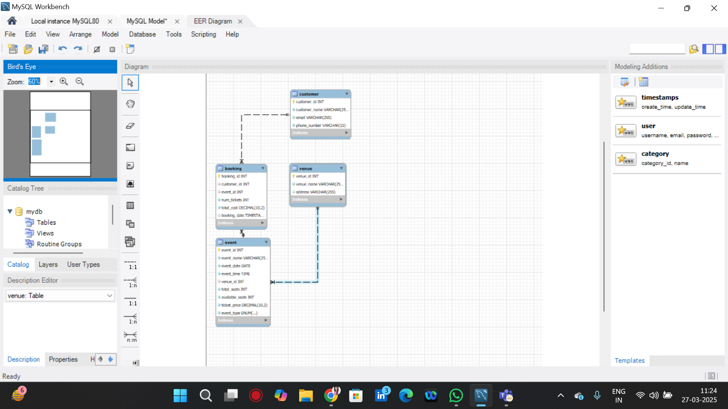

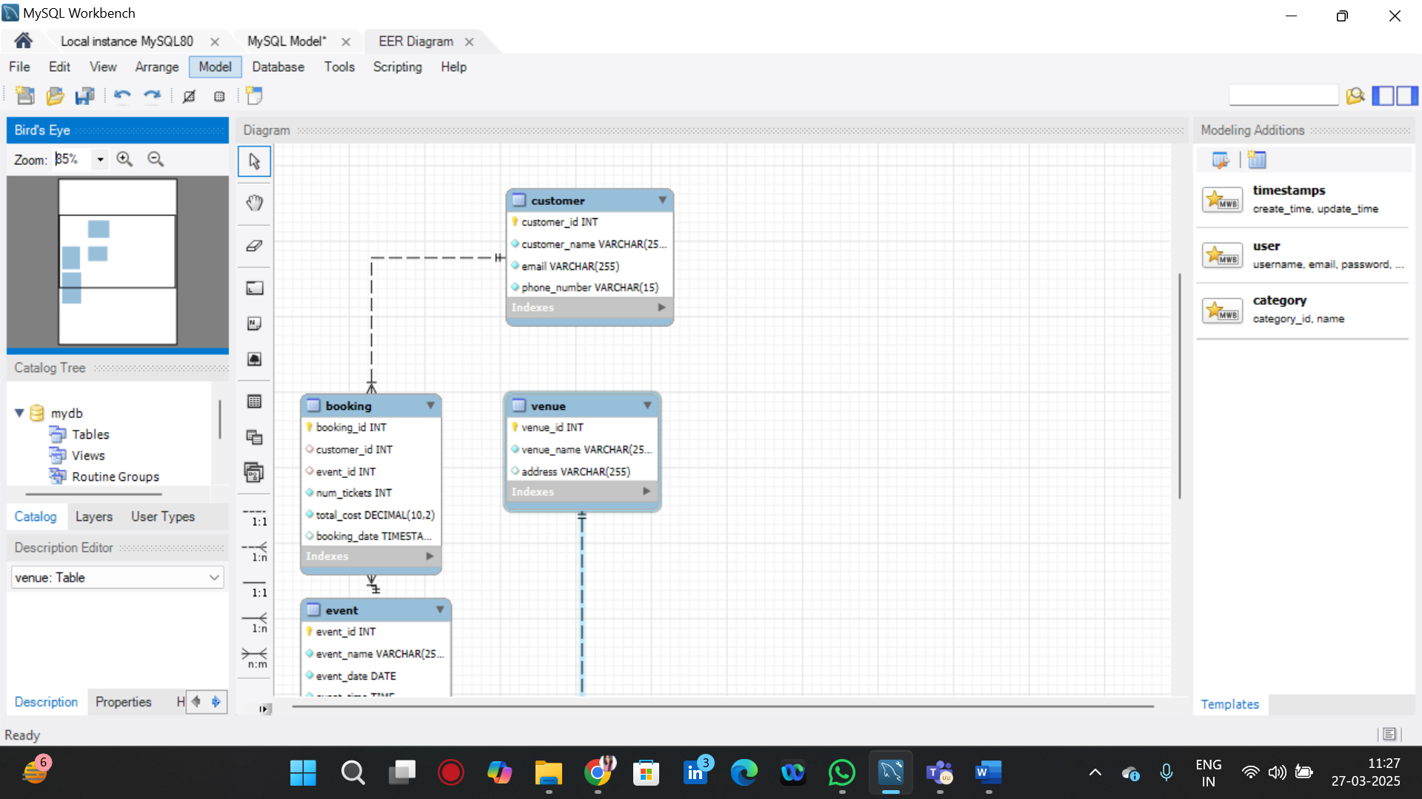

TASK 1 = CREATING APPROPRIATE PRIMARY KEY AND FOREIGN KEY CONSTRAINTS FOR REFERENTIAL INTEGRITY.

SHOW CREATE TABLE event;

SHOW CREATE TABLE booking;

